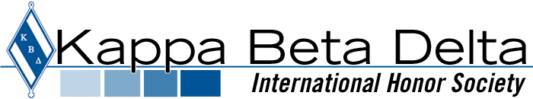

Financial Friday’s Tips

It’s time to start the New Year with a focus on Financial Management and this is your Monthly Financial Tip below:
Having a budget and knowing where every dollar is going allows you to manage your money. A link is provided below with several budget apps and sometimes placing pen to paper and posting in an area that you can see keeps you on target. Whatever you decide, let’s begin the process of managing our financial health and wealth.
https://www.nerdwallet.com/blog/finance/budgeting-saving-tools/
The 7 Best Budget Apps for 2020
At NerdWallet, we strive to help you make financial decisions with confidence. To do this, many or all of the products featured here are from our partners. However, this doesn’t influence our ...
www.nerdwallet.com

Did you know that Kappa Beta Delta provides scholarships? Check out the link below and apply for the Dr. Andrew V. Stevenson International Merit Scholarship. Application Deadline is March 1, 2020.
https://www.kbdhs.org/scholarships

